TITLE

DIPLOMA THESIS

Student:

Project Supervisor:

2023

VISED,

DEAN, HEAD OF DEPARTMENT,
Prof. Eng. Liviu MICLEA, PhD Prof. Eng. Honoriu VĂLEAN, PhD

Student:

TITLE

- The Problem:

- Project Content: Presentation page, Introduction, Theoretical approach, Analysis and design, Implementation, Testing and validation, Conclusions, References and Appendix

- Place of documentation: Technical University of Cluj-Napoca

- Consultants:

- Thesis emission date:

- Thesis delivery date:

Student signature ____________________

Project’s supervisor signature ____________________

Declaraţie pe proprie răspundere privind
autenticitatea proiectului de diplomă

Subsemnatul(a) Prenume NUME , legitimat(ă) cu CI/BI seria nr. , CNP , autorul lucrării:

elaborată în vederea susținerii examenului de finalizare a studiilor de licență la Facultatea de Automatică și Calculatoare, specializarea_________________., din cadrul Universității Tehnice din Cluj-Napoca, sesiunea _______________ a anului universitar 2021-2022, declar pe proprie răspundere, că această lucrare este rezultatul propriei activități intelectuale, pe baza cercetărilor mele și pe baza informațiilor obținute din surse care au fost citate, în textul lucrării, și în bibliografie.
Declar, că această lucrare nu conține porțiuni plagiate, iar sursele bibliografice au fost folosite cu respectarea legislației române și a convențiilor internaționale privind drepturile de autor.
Declar, de asemenea, că această lucrare nu a mai fost prezentată în fața unei alte comisii de examen de licență.
În cazul constatării ulterioare a unor declarații false, voi suporta sancțiunile administrative, respectiv, anularea examenului de licență.

Data: Prenume NUME
____
(semnătura)

SYNTHESIS
of the Diploma Thesis:
TITLE

Student:
Project Supervisor:

- Problem definition:

- Application domain:

- Obtained Results:

- Testing and Verification:

- Personal Contributions:

- Documentation Sources: Technical books, internet, experts in the field.

Student signature _______________

Project’s supervisor signature _______________

Contents
Contents 1
1 Introduction 2
1.1 Overview 2
1.2 Objectives 2
1.3 Specifications 2
2 State of the art 3
3 Analysis, design and implementation 9
4 Conclusions 10
4.1 Achivements 10
4.2 Future work 10
5 References 11
6 Appendix 12

Introduction

Overview
În introducere familiarizați cititorul cu motivația lucrării, plasați lucrarea într-un context care să permită cititorului să înțeleagă obiectivele.
Descrieți importanța lucrării, de ce merita să o faceți, plasați ideile într-un context larg.
Susțineți studiul: de ce exact aceasta aplicație/implementare. Comentați asupra aspectelor teoretice sau practice care v-au făcut să o alegeți.
În funcție de natura lucrării, ar putea fi necesar să prezentați informații de fond asupra domeniului în care se încadrează aplicația, mai ales dacă aveți o lucrare într-un domeniu multidisciplinar. În acest caz, puteți introduce terminologia pe care o utilizați în continuare.
Descrieți pe scurt lucrarea: ce conține fiecare capitol.

Objectives
Enumerați și explicați obiectivele lucrării: ce v-ați propus să realizați în contextul prezentat anterior.
Obiectivele pot fi prezentate sub formă de listă care să evidențieze precis orientarea lucrării, să identifice conceptele fundamentale pe care le studiați, să stabilească scopul aplicației pe care o realizați, sau enunțați întrebările la care intenționați să răspundeți în lucrare.

Specifications
În specificațiile lucrării detaliați cerințele. Descrieți ce intenționați să obțineți. Vă puteți referi la funcțiile aplicației, interfață, nivele de performanță, structuri de date, elemente, securitate, fiabilitate, calitate, limitări, etc.

State of the art
Conține o analiză a ceea ce s-a realizat/studiat anterior. Arătați că ați studiat materiale bibliografice și că ați înțeles ceea ce ați citit.
Puteți include diferite puncte de vedere asupra problemei pe care o rezolvați în lucrare.
Nu uitați să citați corespunzător autorii oricărei idei extrase dintr-o sursă bibliografică
Over the last few decades, the information available to us increased exponentially, thus making it impossible to check its authenticity. For this reason, platforms like FastLearn have become necessary in our day-to-day life. This project aims to ease the learning experience by developing an interactive web application with accurate information supplied by experts in their respective fields. Given the scarcity of verified information on the internet, there are multiple e-learning platforms that aim to help anyone who wants to expand their knowledge. A few examples are: SQLZOO[1], GeeksForGeeks[2], Udemy[3], Coursera and many others.
A diligent analysis was made regarding three of the web platforms mentioned in the above paragraph.
SQLZOO is a free-to-use learning environment destined for both beginner and experienced programmers looking to improve their SQL (Structured Querry Language) skills. Its modest but intuitive design offers an easy-to-follow learning path for beginners. The design of the platform can be observed in below.
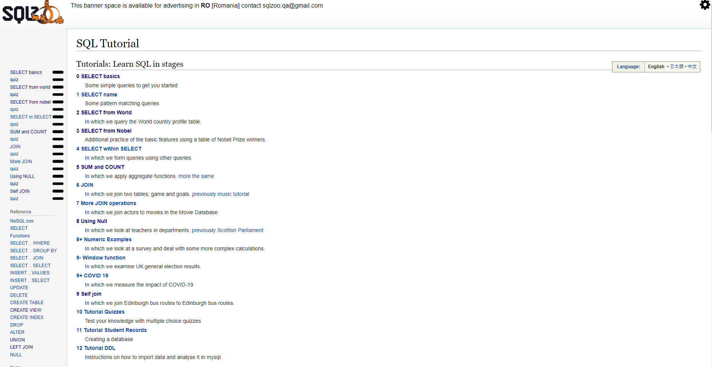
Figure 2.1 - SQLZOO landing page
The learning material is structured in lessons, each using and building upon the previously studied concepts. The classes are composed of a series of practical assignments gradually increasing in difficulty. The exercises require the user to formulate a valid query to interrogate the provided database and return the desired output. Upon writing a potential solution, the user can run it directly on the platform and receive instant feedback regarding his solution. In Figure 2.2, the functionalities presented above are illustrated.
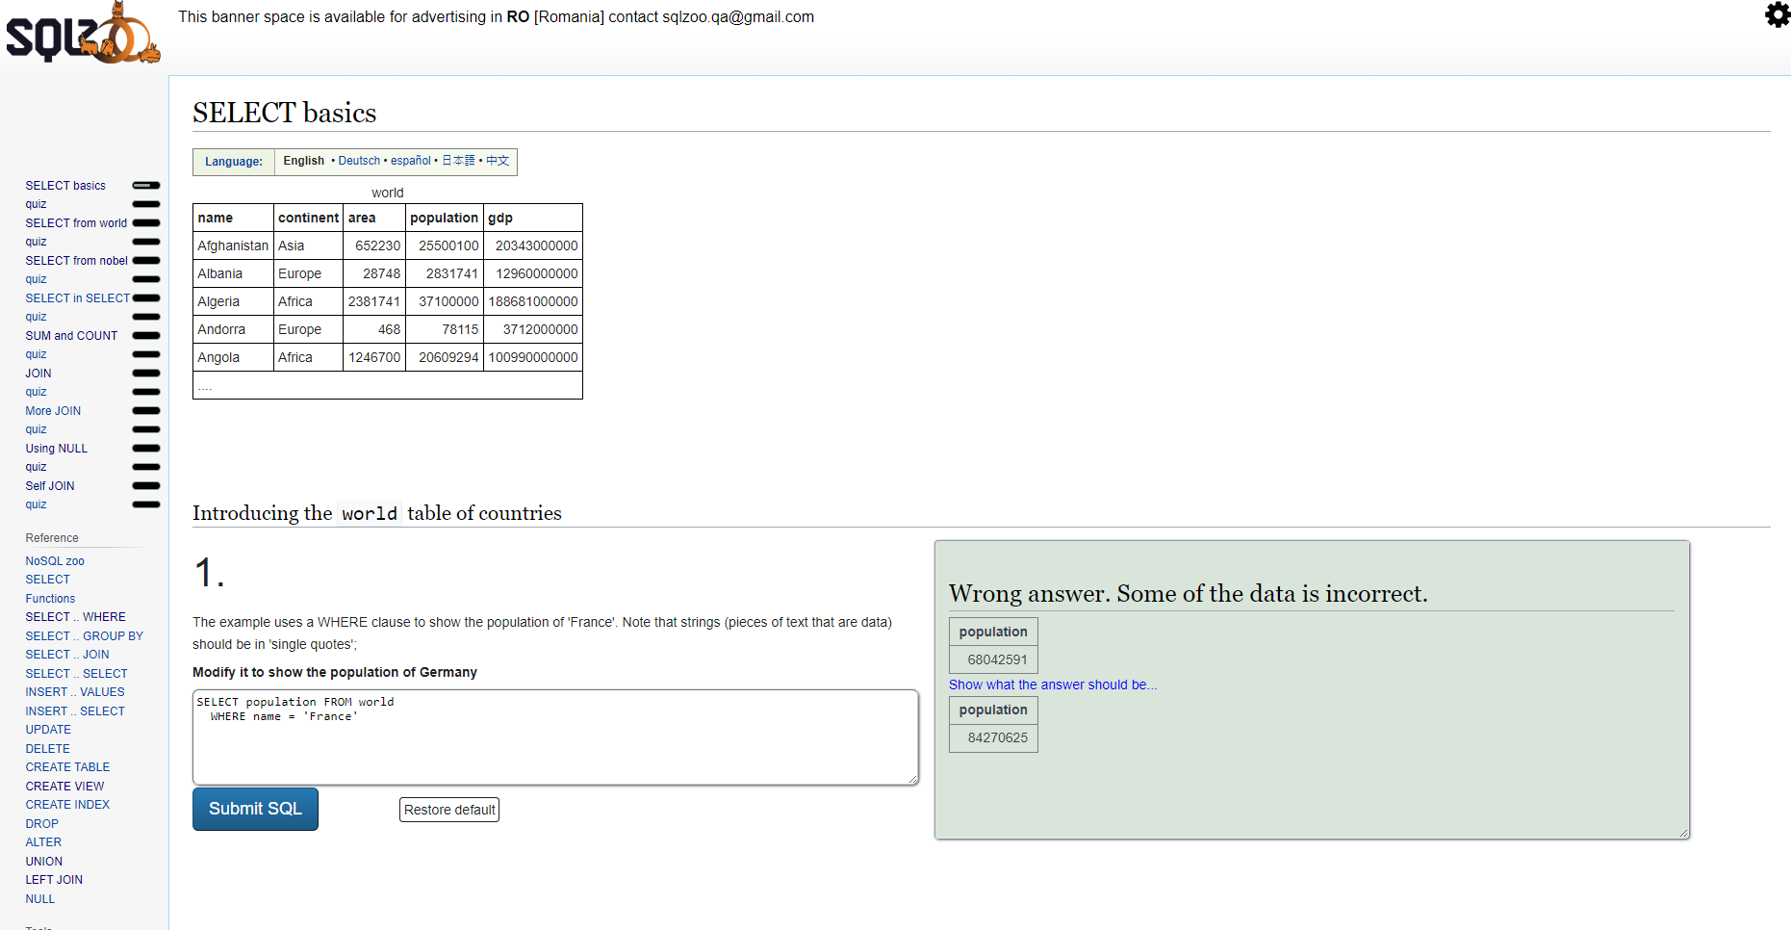
Figure 2.2 - SQLZOO lesson overview
At the beginning of the lesson, a quick view of the database, in our instance, the „world“ table, is given. Quickly after this, the first assignment is presented. From now on, it is up to the user to write a potential solution in the designated space and test it. InFigure 2.2, the user receives feedback in case of an incorrect solution. Initially, only the first table is provided, and if the user so desires, the correct result of the query can be viewed by clicking on the button „Show what the answer should be...“.
The previously presented features are available without creating an account, which is ideal for quickly accessing and dusting up one‘s knowledge on the desired topic. While using SQLZOO like this is viable for experienced programmers, for a beginner, it is recommended to have own an account. One of the advantages of a logged-in user is the possibility to track their progression and examine solutions to past exercises. This feature allows a novice to revise the already mastered knowledge effectively.
SQLZOO is, without a shadow of a doubt, a great learning resource, as it offers a comprehensive learning path to learn SQL that will enhance one's individual learning experience. When comparing it with the topic of this thesis, FastLearn, the latter stands out due to its emphasis on collaboration. It encourages its users to participate in one-on-one dedicated sessions to help the student in need understand the topic better. This method builds upon the individual study approach and offers insights the user wouldn't have encountered otherwise.
The second application, GeeksForGeeks, is an online platform designed to help any programming passionate enhance their skill. With an intuitive user interface, it encapsulates a wide range of articles, courses, tutorials, and practice exercises in various programming languages. A significant portion of the content is available free of charge. The content is gradually made available to users, ranging from unregistered to paying users. Without an account, a user can access tutorials on many topics, as seen in Figure 2.3.
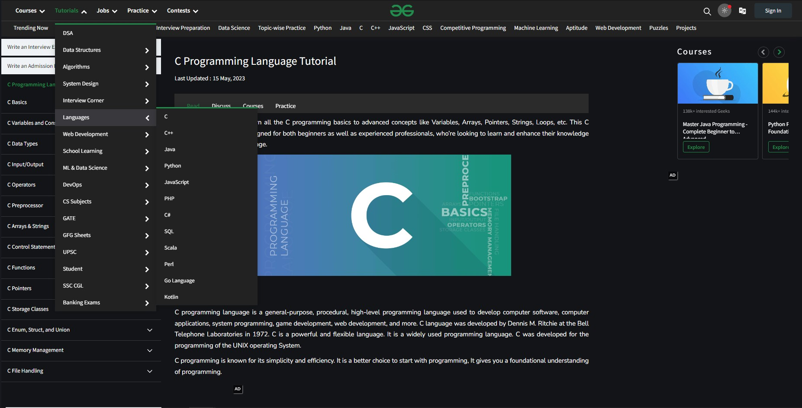
Figure 2.3 - GeeksForGeeks tutorial categories
Using the website as an unlogged user may fulfill the needs of some, but the advantages of registering on GeeksForGeeks are undoubtedly plenty. One of the advantages of creating an account is having access to the large collection of practice problems and solving those problems directly on the site, in their IDE, which can be observed in Figure 2.4. Another benefit of being registered is interacting and testing your knowledge by competing with other users. Lastly, one can sign up for a course by paying an enrollment fee. Enrolling in such a course will grant access to detailed video content and other course-specific features.
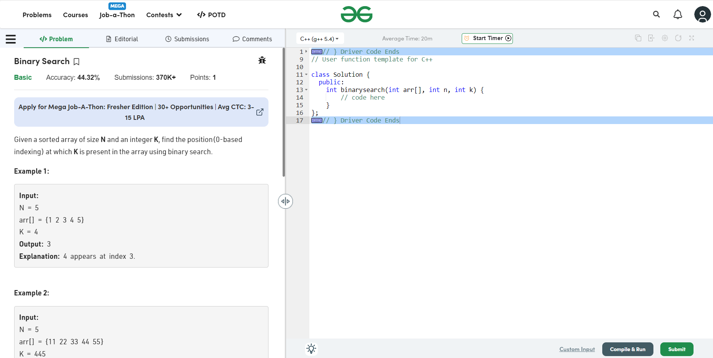
Figure 2.4 - GeeksForGeeks exercise page
GeeksForGeeks is a reliable platform well-suited for learning, but there is no free assistance for users that need a little bit more help to understand a particular concept. The topic of this thesis, FastLearn, solves this issue by introducing a new user role. This new user is incentivized to help students in need in one-to-one chat sessions by earning platform currency.
While GeeksForGeeks is a user-friendly and reliable resource for anyone who wants to enhance their programming skills, the last learning website analyzed, Udemy, is more suitable for someone who looks for more general topics. The broader selection of course subjects hosted on Udemy makes it a better choice for the general user. Some of the categories can be observed inFigure 2.5.
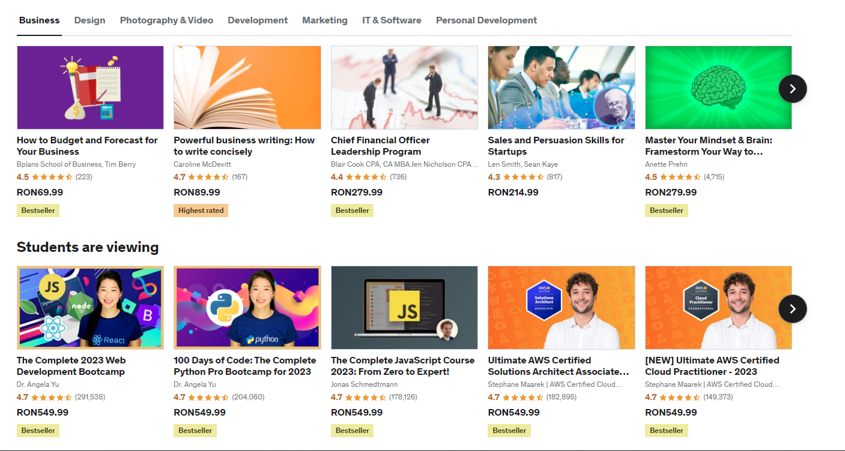
Figure 2.5 - GeeksForGeeks landing page
Udemy is an online learning platform aiming to foster a global learning environment. The website offers its services to both personal users and businesses. The general user can create a personal account, while businesses can opt for special company accounts. Creating a personal account gives you access to free content, a scheduler for learning activities, and filters that will help you find the best resource. Most courses on the website require an enrollment fee. Before paying, the user can browse the curriculum to understand better the topics covered in the video materials that will be made available once joining the course. Based on the specific offer, some advantages may be life-long access, special practical assignments, and gaining a certificate upon completion. The landing page for a logged in user can be observed below inFigure 2.6.
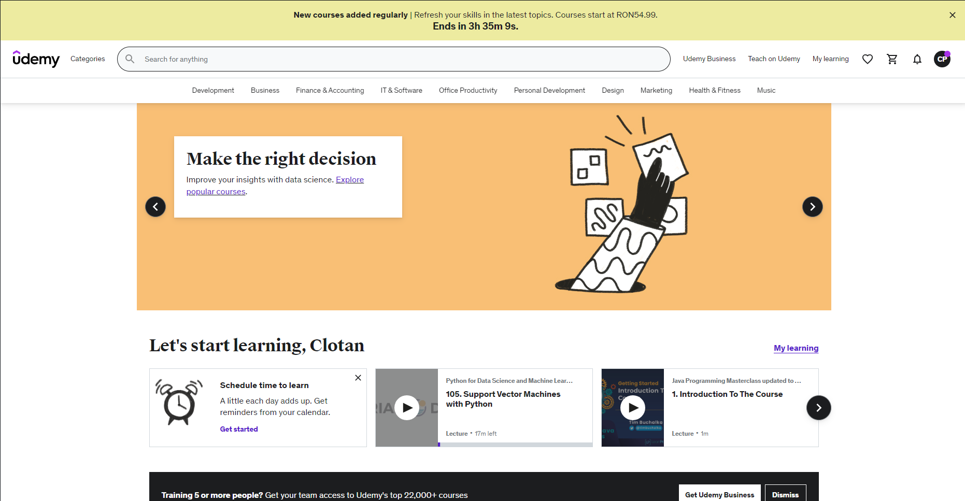
Figure 2.6 - Udemy logged-in user landing page
While Udemy is well-suited for individual use, it has plans designed to meet the needs of small to large companies. Udemy Business is a subscription-based service for companies which grant access to top courses selected from Udemy.com, available on any device. Based on the selected plan, the company can create custom learning paths and get advanced analytics and insights through a special account. The employees of the company gain access to a carefully selected collection of courses. The landing page for Udemy Business can be seen below inFigure 2.7.
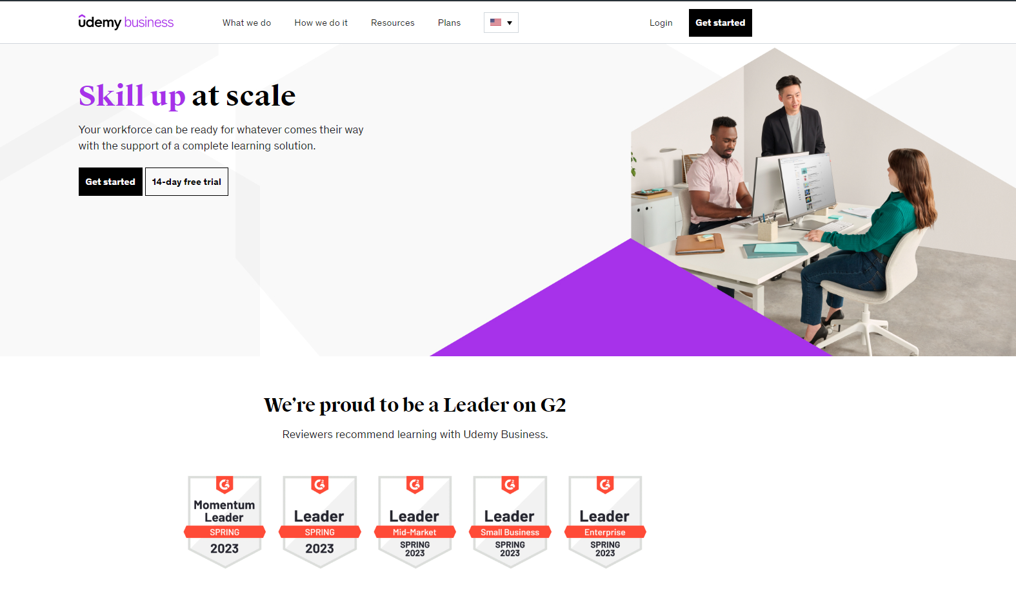
Figure 2.7 - Udemy Business
Udemy offers insightful video materials that will help refine a particular skill through self-study. However, the topic of this thesis, FastLearn, advocates for a collaborative approach. It encourages its users to participate in one-on-one dedicated sessions to help the student in need understand the topic better. This method builds upon the individual study approach and offers insights the user wouldn't have encountered otherwise.
In conclusion, all three applications that were discussed provide significant insights. The first platform, SQLZOO offers an excellent example of what an intuitive learning path for programmers at all levels should look like. The second platform, GeeksForGeeks perfectly illustrates how one can integrate the lessons taught by SQLZOO and delivers high-quality content in a modern and easy-to-use user interface. The third and last analyzed platform, Udemy is a well-known website portraying a good business model and a testament to the importance of resources similar to the theme of this thesis, FastLearn.

Analysis, design and implementation
Aceasta parte a lucrării este flexibilă și depinde foarte mult de natura lucrării, poate fi organizată în mai multe capitole și conține contribuțiile personale ale autorului.
Includeți:
- Detalii referitoare la analiză și proiectare:
▪ descrierea metodelor pe care le-ați aplicat pentru rezolvarea problemei,
▪ descrierea materialelor, procedurilor
▪ calcule, tehnici, descrierea echipamentelor
▪ metodologia de proiectare
▪ informațiile necesare pentru ca cineva să poată reface lucrarea
- Implementare :
▪ Descrieți detaliile tehnice ale implementării aplicației: mediul de implementare, modul de prezentare, modul de utilizare al aplicației, etc.
- Testare si validare :
▪ Descrieți metodologia de testare a aplicației și rezultatele
▪ Includeți experimentele pe care le-ați realizat, analiza rezultatelor pe care le-ați obținut.

Conclusions

Achivements
Evidențiați toate rezultatele pe care le-ați obținut și trageți concluzii din ele. Puteți prezenta o analiză critică a ceea ce ați realizat comparativ cu alte lucrări/studii anterioare.
Includeți o listă a contribuțiilor pe care le-ați avut în domeniul temei abordate.

Future work
Descrieți direcțiile posibile de dezvoltare.

References

[1] SQLZOO website [Online]. Available: https://sqlzoo.net/wiki/SQL_Tutorial
[2] GeeksForGeeks website [Online]. Available: https://www.geeksforgeeks.org/
[3] Udemy website [Online]. Available: https://www.udemy.com/

Appendix

